GOVERNMENT OF INDIA
Ministry of Commerce & Industry | NICDC
Industrial Corridor Project Management System (IC-PMS)

MODULE 9
Reporting &
Analytics
Unified Programme Intelligence | Executive Dashboards | MPR Auto-Generation | KPI Analytics | GIS Heatmaps
Detailed Design Document

Document Version: 1.0 | March 2026 | Classification: Restricted
Prepared by: IC-PMS Solution Architect Team | NICDC / Ministry of Commerce & Industry

1. Module Overview

1.1 Purpose & Objectives
Module 9 — Reporting & Analytics — is the intelligence and communication layer of IC-PMS. It is the convergence point where data from all eight operational modules is synthesised, transformed, and presented as actionable intelligence for every level of the programme governance hierarchy — from the site engineer's weekly task list to the Cabinet Committee on Economic Affairs (CCEA) briefing note. Module 9 does not generate any project data itself; it reads, aggregates, analyses, and presents the data that Modules 1 through 8 produce.
The module addresses one of the most persistent failures in Indian government infrastructure programmes: reporting is manual, delayed, inconsistent, and often sanitised by the time it reaches senior decision-makers. IC-PMS Module 9 replaces this with automated, real-time, data-driven reporting — the Monthly Progress Report (MPR) is auto-generated in under 10 minutes from the first of each month, not assembled over two weeks by a team of planners. The Executive Dashboard refreshes every 15 minutes with live data from all modules. The KPI Analytics Engine flags deteriorating performance trends before they become crises.
Module 9 also hosts the Custom Report Builder — a drag-and-drop interface that allows NICDC programme managers, SPV finance teams, and lender monitoring agents to create their own tailored reports from the IC-PMS data warehouse without writing SQL or engaging IT. Every report template created is saved, schedulable, and distributable — transforming reporting from a recurring effort into a one-time design exercise.
A distinctive feature is the AI-assisted narrative engine — using a large language model (LLM) to draft the executive narrative section of the MPR from structured data. Instead of a planner spending half a day writing 'The SPI for DMIC-N03 was 0.87 in March 2026, representing a decline from 0.89 in February...', the system generates a first draft of this paragraph in seconds, which the PMC Lead then reviews and approves. The LLM runs on NIC MeghRaj (sovereign infrastructure) — no data leaves government cloud.

1.2 Module Scope
Capability | Included | Technology / Standard
Real-time executive dashboard (configurable, role-based) | Yes | React + Recharts; Elasticsearch; 15-min refresh
Monthly Progress Report (MPR) auto-generation (PDF + Word + HTML) | Yes | JasperReports + Python matplotlib; LLM narrative assist
KPI analytics engine — 30 programme-level KPIs across 6 dimensions | Yes | NICDC KPI framework; EVM ANSI 748; PMBOK
Programme GIS heatmap (SPI, CPI, Risk, Progress, EDI overlays) | Yes | MapLibre GL; GeoServer; PostGIS; Module 3 satellite integration
Custom report builder — drag-and-drop, no-code interface | Yes | React drag-and-drop; configurable widget library
Alert and notification engine (threshold-based, cross-module) | Yes | Elasticsearch alerting; SMTP + SMS + in-app
Data warehouse (DW) with ETL from all 8 modules | Yes | PostgreSQL + Elasticsearch; Apache Airflow ETL; daily/real-time
Report distribution management (email, SMS, portal, API) | Yes | SMTP / SMS gateway; NICDC portal; REST API for lenders
Lender progress reporting (ADB, JICA, World Bank format) | Yes | Customisable lender report templates
Parliamentary / CAG / CVC compliance reports | Yes | Standardised government audit report formats
AI-assisted narrative drafting for MPR executive sections | Yes | NIC MeghRaj LLM (sovereign); human review mandatory
Historical trend analysis and predictive analytics | Yes | Time-series analysis; regression; ARIMA forecasting
Report archive with 30-year retention (integrated with Module 6 DMS) | Yes | NIC DigiLocker; Module 6 DMS integration
Mobile-responsive dashboards for field and executive access | Yes | Progressive Web App (PWA); responsive React

1.3 Key Design Principles
- Data warehouse as single source of truth: All Module 9 reports draw from the DW — never directly from operational module databases. This prevents reporting queries from impacting operational system performance and enables consistent, point-in-time snapshots for audit purposes
- Zero manual data entry in reporting: Every number in every IC-PMS report is derived from operational module data — no planner should manually type a figure into a report template. If a number is not in the system, the report flags it as 'Data Not Available' rather than accepting a manually entered value
- Role-based information architecture: A Ministry Secretary, NICDC MD, SPV PM, PMC Resident Engineer, and contractor all see different dashboards appropriate to their decision-making authority — the same KPIs at different levels of aggregation and detail
- AI narrative as draft, not final: The LLM-generated narrative is clearly marked as 'AI Draft — Requires PMC Review'; the PMC Lead must review and approve before the MPR is published. The AI assists but does not replace professional judgement
- Lender reporting parity: ADB, JICA, and World Bank have specific reporting templates and data requirements; Module 9 maintains lender-specific report configurations so that lender reporting is as automated as internal NICDC reporting
- Predictive analytics for early warning: Module 9 uses time-series regression to detect deteriorating KPI trends 4–6 weeks before they breach alert thresholds — enabling proactive intervention rather than reactive crisis management

2. Sub-Functions — Detailed Requirements

2.1 Sub-Function 9.1 — Executive Dashboard
The Executive Dashboard is the real-time command centre of IC-PMS — a configurable, role-based, live display of programme health that refreshes every 15 minutes. It consolidates data from all eight modules into a single-screen view appropriate for each user's decision-making context: NICDC Programme Director sees the full corridor portfolio; SPV PM sees their node; PMC sees their package set.

Dashboard Architecture
- Widget-based layout: Dashboard composed of configurable widgets — each widget draws from a specific data source (Module 2 EVM, Module 4 Finance, Module 7 Risk, etc.); widgets can be added, removed, resized, and rearranged per user preference
- Role-based defaults: System provides pre-configured default dashboard layouts for each role — NICDC MD layout, SPV PM layout, PMC Lead layout, Finance Officer layout, Lender Monitor layout — users can customise from the defaults
- Real-time refresh: Data warehouse refreshed continuously from Module 2/3/4 live APIs (15-minute cycle); Module 5/6/7/8 refreshed every hour; Dashboard widgets display last-refresh timestamp
- Drill-down navigation: Every KPI value on the dashboard is clickable — clicking 'SPI: 0.87' for DMIC-N03 navigates to the Module 2 schedule analytics for that node
- Programme health RAG: A six-module RAG (Red/Amber/Green) health summary panel — one indicator per module — provides the fastest possible programme status snapshot for senior executives
- Alert feed: Live feed of programme alerts (from Module 7 risk triggers, Module 3 satellite anomalies, Module 4 payment delays, Module 5 BG expiry) in the dashboard sidebar — ordered by severity
- Multi-corridor view: NICDC-level users can switch between DMIC, CBIC, VCIC, AKIC, BMEC, and HNIC corridors in a single dashboard session without logging out

Standard Dashboard Widget Library
Widget Type | Data Source | Refresh Rate | Available For
Programme S-Curve | Module 2 (BCWS/BCWP/ACWP) + Module 4 | 15 min | NICDC, SPV, PMC, Lenders
SPI/CPI Gauge | Module 2 EVM | 15 min | NICDC, SPV, PMC
Node Progress Bar Chart | Modules 2 + 3 (AI Progress) | 15 min | NICDC, SPV, Ministry
Risk Heatmap Thumbnail | Module 7 (P×I Matrix) | 1 hr | NICDC, SPV
Fund Utilisation Donut | Module 4 (Expenditure) | 1 hr | NICDC, SPV Finance, Ministry
Pending RA Bills Ageing | Module 4 (Invoice Queue) | 15 min | SPV Finance, PMC
Equipment Utilisation Bar | Module 8 Histogram | 1 hr | PMC, SPV Operations
Satellite Latest View (WMTS) | Module 3 (GeoServer WMTS) | Weekly (per satellite cycle) | NICDC, SPV, Lenders
Open RFI / NCR Count | Module 6 DMS | 1 hr | PMC, SPV
P80 Cost Overrun Indicator | Module 7 (Monte Carlo) | Monthly (on MC refresh) | NICDC Finance, Ministry, Lenders
Programme Health RAG | All Modules composite | 15 min | NICDC MD, Ministry
Alert Feed | All Modules (threshold triggers) | Real-time | All roles

2.2 Sub-Function 9.2 — Monthly Progress Report (MPR) Generator
The MPR Generator is the automated assembly engine for the Monthly Progress Report — the most important governance document in the IC-PMS reporting calendar. The MPR is the primary monthly briefing document for NICDC Board, Ministry officials, lenders, and SPV Boards. Module 9 generates a complete, formatted MPR in under 10 minutes on the first working day of each month.

MPR Structure and Data Sources
MPR Section | Sub-Sections | Data Source Modules | Charts / Visuals
Executive Summary | Programme status RAG; key highlights; decisions required | All Modules composite; AI Narrative | Programme health dashboard snapshot
Physical Progress | WBS progress % by node/package; AI satellite vs. contractor; milestone status | Module 2 (EVM), Module 3 (AI%) | S-curve, milestone Gantt thumbnail, node progress bars
Financial Performance | EAC vs. BAC; fund utilisation; RA bills status; PFMS reconciliation | Module 4 (Cost Mgmt) | Cost S-curve, EAC trend, fund utilisation pie
Schedule Analysis | SPI by node/package; critical path status; look-ahead; float analysis | Module 2 (Schedule EVM) | SPI trend chart, CP activities table, look-ahead bar chart
Satellite & GIS Update | AI progress map; encroachments; CVI by node; NDVI trend | Module 3 (Satellite) | Satellite imagery thumbnails, CVI bar chart, NDVI trend
Risk Summary | Top 10 risks (RED/AMBER); P80 MC estimate; new risks this month; closed risks | Module 7 (Risk Mgmt) | Risk heat map, P80 S-curve, tornado chart
Contract & Procurement | Tender pipeline; active contracts at risk; VO summary; BG expiry | Module 5 (Contract Mgmt) | Procurement pipeline chart, VO bar chart
Resource Performance | Labour deployment vs. plan; equipment utilisation; over-allocations | Module 8 (Resource Mgmt) | Labour histogram, equipment utilisation chart
Document Management | Drawing IFC%; transmittal overdue; RFI ageing; submittal status | Module 6 (DMS) | Drawing completion bar, RFI ageing table
Annex: Data Tables | Full EVM table by WBS; RA bill register; risk register extract; drawing register | All Modules | Formatted data tables

Functional Requirements
- Automated assembly trigger: Kubernetes CronJob runs at 02:00 IST on the 1st of each month; data warehouse snapshot taken for the previous month's data date; MPR generation pipeline initiated
- Section completeness check: Before generating the MPR, system checks that all required data is available from each module — if any module has not completed its month-end update, system sends alert and waits up to 6 hours before generating with 'Data Unavailable' placeholder
- Chart generation: Python matplotlib generates all charts (S-curves, bar charts, heatmaps, trend lines) as high-DPI PNG files; charts embedded in the MPR with caption and data source attribution
- AI narrative drafting: LLM (hosted on NIC MeghRaj) receives structured data for each MPR section and generates an executive narrative paragraph; narrative clearly marked as 'AI Draft'; PMC Lead edits and approves each section
- Review workflow: Draft MPR submitted to PMC Lead for review → PMC Lead section-by-section approval → SPV Director countersign → MPR published; entire review workflow tracked in system with timestamps
- Multi-format output: MPR generated simultaneously as: PDF (for distribution), Word (for editable version), HTML dashboard (for portal display); all three versions archived in Module 6 DMS
- Hindi executive summary: A 1-page Hindi executive summary auto-translated from the English executive summary using NIC language services; included in MPR as Annex

2.3 Sub-Function 9.3 — KPI Analytics Engine
The KPI Analytics Engine maintains a comprehensive library of programme performance indicators — 30 KPIs across 6 dimensions — computing their values from module data, tracking trends, comparing against targets, and generating early warning alerts when KPIs are on a deteriorating trajectory that will breach red thresholds.

KPI Framework — 6 Dimensions, 30 KPIs
Dimension | KPI | Formula / Source | Green Target | Red Threshold
Schedule Performance (M2) | SPI (Schedule Performance Index) | BCWP / BCWS — Module 2 | ≥ 1.00 | < 0.85
Schedule Performance (M2) | Critical Path Float (days) | Min Total Float on CP — Module 2 | > 14 days | = 0 days (no float)
Schedule Performance (M2) | Milestone Hit Rate (%) | Milestones on time / Total due × 100 — Module 5 | > 90% | < 70%
Cost Performance (M4) | CPI (Cost Performance Index) | BCWP / ACWP — Module 2 + 4 | ≥ 1.00 | < 0.85
Cost Performance (M4) | EAC vs. BAC (%) | (EAC / BAC – 1) × 100 — Module 4 | < 0% | > +10%
Cost Performance (M4) | P80 Cost Overrun (₹ Cr) | MC P80 – Deterministic EAC — Module 7 | < ₹ 200 Cr | Above contingency reserve
Physical Progress (M3) | AI Progress vs. Plan (%) | AI% – Planned% — Modules 2, 3 | 0 to +5% | < –10%
Physical Progress (M3) | CVI — Construction Velocity (Ha/wk) | New active area per week — Module 3 | > 150 Ha/wk | < 80 Ha/wk
Physical Progress (M3) | Satellite-Contractor Variance (%) | Contractor% – AI% — Module 3 | < 5% | > 10%
Risk & Compliance (M7) | RED Risk Count | Count of risks rated Red/Crimson — Module 7 | < 5 | ≥ 15
Risk & Compliance (M7) | P80 Schedule Delay (days) | MC P80 schedule delay — Module 7 | < 14 days | > 60 days
Contract Management (M5) | VO Utilisation (% of LOA) | Cumulative VO / LOA × 100 — Module 5 | < 5% | ≥ 9%
Contract Management (M5) | Contractor Performance Score | Weighted 8-KPI score — Module 5 | > 80 | < 60
Contract Management (M5) | Bill Approval Cycle (days) | Average days from submission to payment — Module 4 | < 15 days | > 30 days
Resource Performance (M8) | Labour Deployment Rate (%) | Actual / Planned headcount × 100 — Module 8 | > 90% | < 70%
Resource Performance (M8) | Equipment Utilisation (%) | Actual hours / Available hours × 100 — Module 8 | 80–95% | < 60% or > 98%
Document Management (M6) | Drawing IFC Completion (%) | IFC drawings / Total registered × 100 — Module 6 | > 85% | < 60%
Document Management (M6) | RFI Response Time (days avg) | Average days to close open RFIs — Module 6 | < 5 days | > 14 days

Functional Requirements
- KPI computation: All 30 KPIs computed daily from Data Warehouse; values stored in D3 (KPI Store) with period date for trend tracking
- Trend detection: For each KPI, a 6-period (6-week or 6-month) linear regression computed to detect trend direction (improving, stable, deteriorating) and projected date to threshold breach — 'At current trend, SPI will breach Red (0.85) threshold in 4 weeks'
- Sparkline charts: 7-period sparkline for each KPI shown on the KPI analytics screen — instant visual trend recognition without needing to analyse data
- Comparative benchmarking: KPI values compared across all corridor nodes in a league table view — identifying which nodes are best performing and which need intervention
- KPI alert thresholds: Each KPI has configurable Green, Amber, and Red thresholds; breach of Amber threshold generates notification; breach of Red threshold generates escalation alert to NICDC Programme Director
- KPI definition library: NICDC can add, modify, and deactivate KPI definitions without IT involvement — the formula and data source are configured through a no-code interface by the NICDC PMO KPI Administrator

2.4 Sub-Function 9.4 — Programme GIS Heatmap
The Programme GIS Heatmap provides a geographical view of programme performance — colour-coding each corridor node and alignment by its performance on a selected KPI. It is the most intuitive tool for senior NICDC officials and Ministry briefings — a single map showing which parts of India's industrial corridor programme are performing well and which need attention.

Functional Requirements
- Base map: India administrative map with all six industrial corridors (DMIC, CBIC, VCIC, AKIC, BMEC, HNIC) as overlays; corridor alignments shown as polylines; nodes shown as clickable circle markers
- KPI overlay selector: User selects the KPI to visualise — SPI, CPI, AI Progress%, Risk Rating, EDI, Encroachment Count, or Resource Utilisation; map colour-coding immediately updates to show that KPI's values
- Colour scale: Standard heat map scale — green (good), yellow (warning), orange (moderate concern), red (serious concern) — with the specific value range labelled per KPI; scale shown as a legend
- Node click drill-down: Clicking a node marker opens a node detail panel showing all key KPIs for that node, most recent satellite image thumbnail, and navigation buttons to relevant operational modules
- Corridor comparison table: Alongside the map, a summary table compares all nodes on the selected KPI — sortable by KPI value, allowing instant identification of best and worst performers
- Time animation: 'Play' button animates the heatmap through monthly snapshots for the past 12 months — showing how performance has evolved geographically over time
- Export: Map view exportable as georeferenced PNG for Ministry presentations; data exportable as GeoJSON with KPI values for further GIS analysis

2.5 Sub-Function 9.5 — Custom Report Builder
The Custom Report Builder provides a no-code, drag-and-drop interface for creating bespoke reports from IC-PMS data. Any authorised NICDC or SPV user can design a report by selecting data widgets, arranging them on a canvas, configuring their parameters, and saving the report as a schedulable template — without writing SQL, configuring JasperReports, or engaging IT support.

Functional Requirements
- Widget palette: All standard IC-PMS charts, tables, KPI cards, maps, and text blocks available as draggable widgets in the palette; widgets categorised by data domain (EVM, Cost, Risk, Satellite, Contract, Resource, Documents)
- Canvas layout: Infinite-scroll report canvas with snap-to-grid; widgets can be resized, moved, layered; page breaks insertable for multi-page reports; A4 and US Letter page size options
- Widget configuration: Each widget has a properties panel — data source (module + entity), scope filter (corridor/node/package), time period, display style, colour scheme, conditional formatting rules
- Real-time preview: As user configures widgets, the canvas shows live preview data (or sample data if live data requires heavy computation)
- Report scheduling: Built report can be scheduled for auto-generation at any frequency (daily, weekly, monthly, quarterly); scheduled reports auto-published to configured distribution lists
- Report sharing: Saved reports shareable with other users via link; shared reports show as read-only for recipients; owner can grant edit access
- Report templates library: Pre-built templates for common use cases — Lender Quarterly, CAG Audit Pack, Ministry QRT, SPV Finance, PMC Operations — available as starting points
- Version history: All saved versions of a report definition retained; any earlier version restorable; changes tracked with user and timestamp

2.6 Sub-Function 9.6 — Alert & Notification Engine
The Alert Engine continuously monitors all KPIs, data quality indicators, and operational events across IC-PMS and generates structured, prioritised notifications to the right people through the right channels at the right time.

Alert Types and Delivery
Alert Type | Source | Priority | Delivery Channel | SLA
Critical Risk Trigger (Crimson/Red) | Module 7 (risk trigger) | P1 — Emergency | Email + SMS + In-app + NICDC Portal | < 15 minutes from trigger
KPI Red Threshold Breach | Module 9 (KPI Engine) | P2 — Urgent | Email + In-app | < 30 minutes from breach
Payment Delay (> 30 days) | Module 4 (Invoice) | P2 — Urgent | Email + In-app to SPV Finance | < 1 hour
Satellite Encroachment Alert | Module 3 (Satellite) | P2 — Urgent | Email + In-app + NICDC Portal | < 30 minutes from anomaly detection
BG/PBG Expiry (< 30 days) | Module 5 (Contract) | P3 — Warning | Email + In-app | Daily at 08:00
KPI Amber Threshold Breach | Module 9 (KPI Engine) | P3 — Warning | Email + In-app | < 1 hour from breach
MPR Approval Overdue | Module 9 (MPR workflow) | P3 — Warning | Email | At SLA 50% point; again at 100%
Drawing IFC SLA Breach (> 10 days) | Module 6 (Drawing Register) | P4 — Info | In-app + Email to PMC | Daily digest
Resource Over-Allocation (Severe) | Module 8 (Resource Mgmt) | P4 — Info | In-app to PMC Planner | Within 1 hour of detection
Data Warehouse ETL Failure | Module 9 (ETL Engine) | P2 — Urgent | Email + SMS to NICDC IT | < 5 minutes from failure

Functional Requirements
- Elasticsearch Watcher: All KPI thresholds configured as Elasticsearch Watcher rules — the DW is continuously monitored; threshold breaches detected within the refresh cycle latency
- Subscription management: Users can subscribe/unsubscribe to specific alert types; personal alert preferences stored (e.g., 'Receive SMS only for P1 and P2 alerts; email for P3 and P4')
- Alert deduplication: If the same condition fires multiple times within a configurable window, system sends one consolidated alert — not repeated individual alerts for the same event
- Alert acknowledgement: Each alert requires acknowledgement from the recipient; unacknowledged P1 alerts escalate after 30 minutes; unacknowledged P2 alerts escalate after 2 hours
- Alert audit trail: All fired alerts, delivery status, acknowledgement time, and resolution are logged in D6 (Alert Log) — never deleted; queryable for performance management

2.7 Sub-Function 9.7 — Data Warehouse & ETL
The Data Warehouse (DW) is the foundation of all Module 9 analytics — a denormalised, query-optimised copy of all programme data from Modules 1–8. The ETL (Extract, Transform, Load) pipeline continuously harvests data from each module, applies transformations (joining, aggregating, standardising), and loads it into the DW where reporting queries can run without impacting operational system performance.

Data Warehouse Architecture
- Star schema design: Central fact tables (FACT_EVM, FACT_RESOURCE, FACT_RISK, FACT_DOCUMENT, FACT_SATELLITE) surrounded by dimension tables (DIM_WBS, DIM_DATE, DIM_ORGANISATION, DIM_CORRIDOR); standard star schema for fast analytical queries
- Technology stack: PostgreSQL (OLAP-optimised) for structured report data; Elasticsearch for full-text search, KPI alert monitoring, and time-series analytics; Apache Airflow for ETL workflow orchestration on NIC MeghRaj
- Refresh schedule: Module 2 (Schedule/EVM) — every 15 minutes (near real-time); Modules 3, 4 (Satellite, Cost) — every hour; Modules 1, 5, 6, 7, 8 (WBS, Contract, DMS, Risk, Resource) — daily at 02:00 IST; Manual trigger available for any module on demand
- Historical snapshots: Point-in-time DW snapshots saved on the last day of each month — enabling historical comparison and the 'as at [date]' view required for audit and lender reporting
- Data lineage tracking: Every DW record tagged with source module, source table, extract timestamp, transformation version — full data lineage visible from any report value back to the originating operational database record
- ETL failure handling: Failed ETL jobs immediately retry (up to 3 times with exponential backoff); persistent failure generates P2 alert to NICDC IT; affected DW tables marked 'Stale' with last-success timestamp shown on dashboards
- DW capacity: Estimated DW size 500 GB for full 6-corridor 10-year programme; NIC MeghRaj scaling to 5 TB; cold archival to Bharat Cloud after 7 years

2.8 Sub-Function 9.8 — Report Distribution & Archive
Report Distribution manages the delivery of all IC-PMS reports and dashboards to their intended recipients — across email, SMS, the NICDC web portal, external lender portals, and REST API for system-to-system integration. Report archival ensures that every generated report is stored in Module 6 DMS with appropriate retention class and metadata.

Distribution Channels
Channel | Use Case | Technology | Authentication
Email (PDF attachment) | MPR, Risk Reports, Alert emails to named individuals | NICDC SMTP gateway; encrypted PDF for confidential reports | Government email (NIC / NIC email domain)
SMS | P1/P2 alert notifications to mobile numbers | NIC SMS Gateway (SMS Sevak) | Pre-registered mobile numbers; OTP verification
NICDC Web Portal | All reports published to NICDC's internal programme portal | REST API; portal CMS; SSO with NICDC LDAP | NIC SSO / LDAP / Aadhaar-based login
Lender Portal (ADB/JICA/World Bank) | Quarterly and milestone reports; progress certificates | Secure REST API; SFTP for document delivery | API key + client certificate; lender-specific credentials
Module 6 DMS (Auto-archive) | All generated reports auto-filed in DMS under WBS report folder | Module 6 internal API | System service account
WhatsApp (via NIC Business API) | Weekly flash summary for field team leads | Meta Business API / NIC approved gateway | Pre-registered WhatsApp Business numbers

Functional Requirements
- Distribution list management: Each report type has a configurable distribution list — roles (e.g., 'All SPV Directors'), named individuals, and external addresses (lenders, Ministry); list versioned so that historical send records show who was on the list at the time of each dispatch
- Delivery confirmation: System tracks email open/delivery status (via SMTP delivery receipt and read-receipt); SMS delivery report; portal access log; lender API acknowledgement
- Report branding: All generated reports use NICDC letterhead template with Government of India emblem, report classification, and distribution restriction marking
- Scheduled distribution: Reports generated on schedule auto-distributed immediately on generation; on-demand reports distributed on user request; external reports (lenders) distributed only after internal review and approval
- DMS auto-archive: Every published report auto-deposited to Module 6 DMS under the WBS folder path /[Corridor]/[Node]/06_Minutes & Reports/[Report_Type]/[YYYY-MM]; retention class = Permanent for MPR, Long-term (30yr) for operational reports

3. Data Flow Diagrams

3.1 DFD Level 0 — Context Diagram
The Context Diagram presents Module 9 as the Reporting & Analytics Engine (Process 9.0) receiving aggregated data from all Modules 1–8 and the Data Warehouse/ETL engine, and outputting dashboards, MPRs, KPI analytics, GIS heatmaps, custom reports, and alerts to the full programme governance hierarchy — from SPV teams to Ministry of Commerce & Industry.
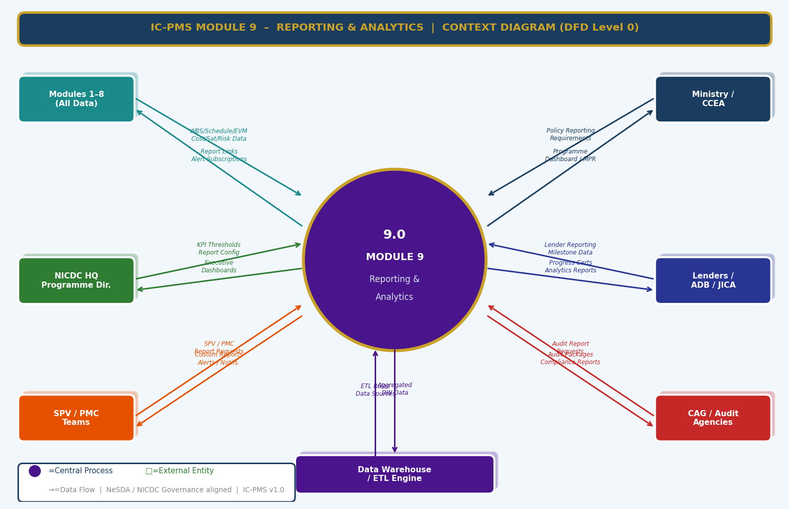
Figure 3.1 — DFD Level 0: Module 9 Context Diagram (All Modules Data Feed, Ministry/Lenders/CAG Outputs, ETL Engine)

External Entity Data Flow Summary
External Entity | Inputs to Module 9 | Outputs from Module 9
Modules 1–8 (All Programme Data) | WBS/Schedule/EVM/Satellite/Cost/Contract/DMS/Risk/Resource data via DW ETL | Data warehouse refresh confirmation; alert subscriptions; report configuration feedback
Ministry / CCEA | Policy reporting requirements, frequency specifications, format requirements | Programme MPR, CCEA briefing note, quarterly progress reports, KPI summary tables
NICDC HQ / Programme Director | KPI target settings, dashboard configuration, report approval decisions | Executive dashboard (live), programme health RAG, MPR (for approval), P80 MC summary
Lenders (ADB / JICA / World Bank) | Lender-specific reporting templates and milestone definitions | Quarterly lender progress reports, milestone progress certificates, financial covenants tracking
SPV / PMC Teams | Report configuration, custom report requests, alert subscriptions | Role-appropriate dashboards, weekly flash reports, custom reports, alert notifications
CAG / Audit Agencies | Audit file requests, compliance report specifications | Complete audit packages (DW snapshot + document links), expenditure statements, trail reports
Data Warehouse / ETL Engine | Aggregated, transformed, time-stamped data from all 8 modules | ETL job schedule, transformation rules, data quality thresholds for pipeline monitoring

3.2 DFD Level 1 — Main Processes & Data Stores
The Level 1 DFD shows eight core reporting and analytics processes and eight data stores. The Data Warehouse (D7) is the central shared data store from which all processes draw — this is the key architectural principle of Module 9: all analytics from a single, consistent data layer.
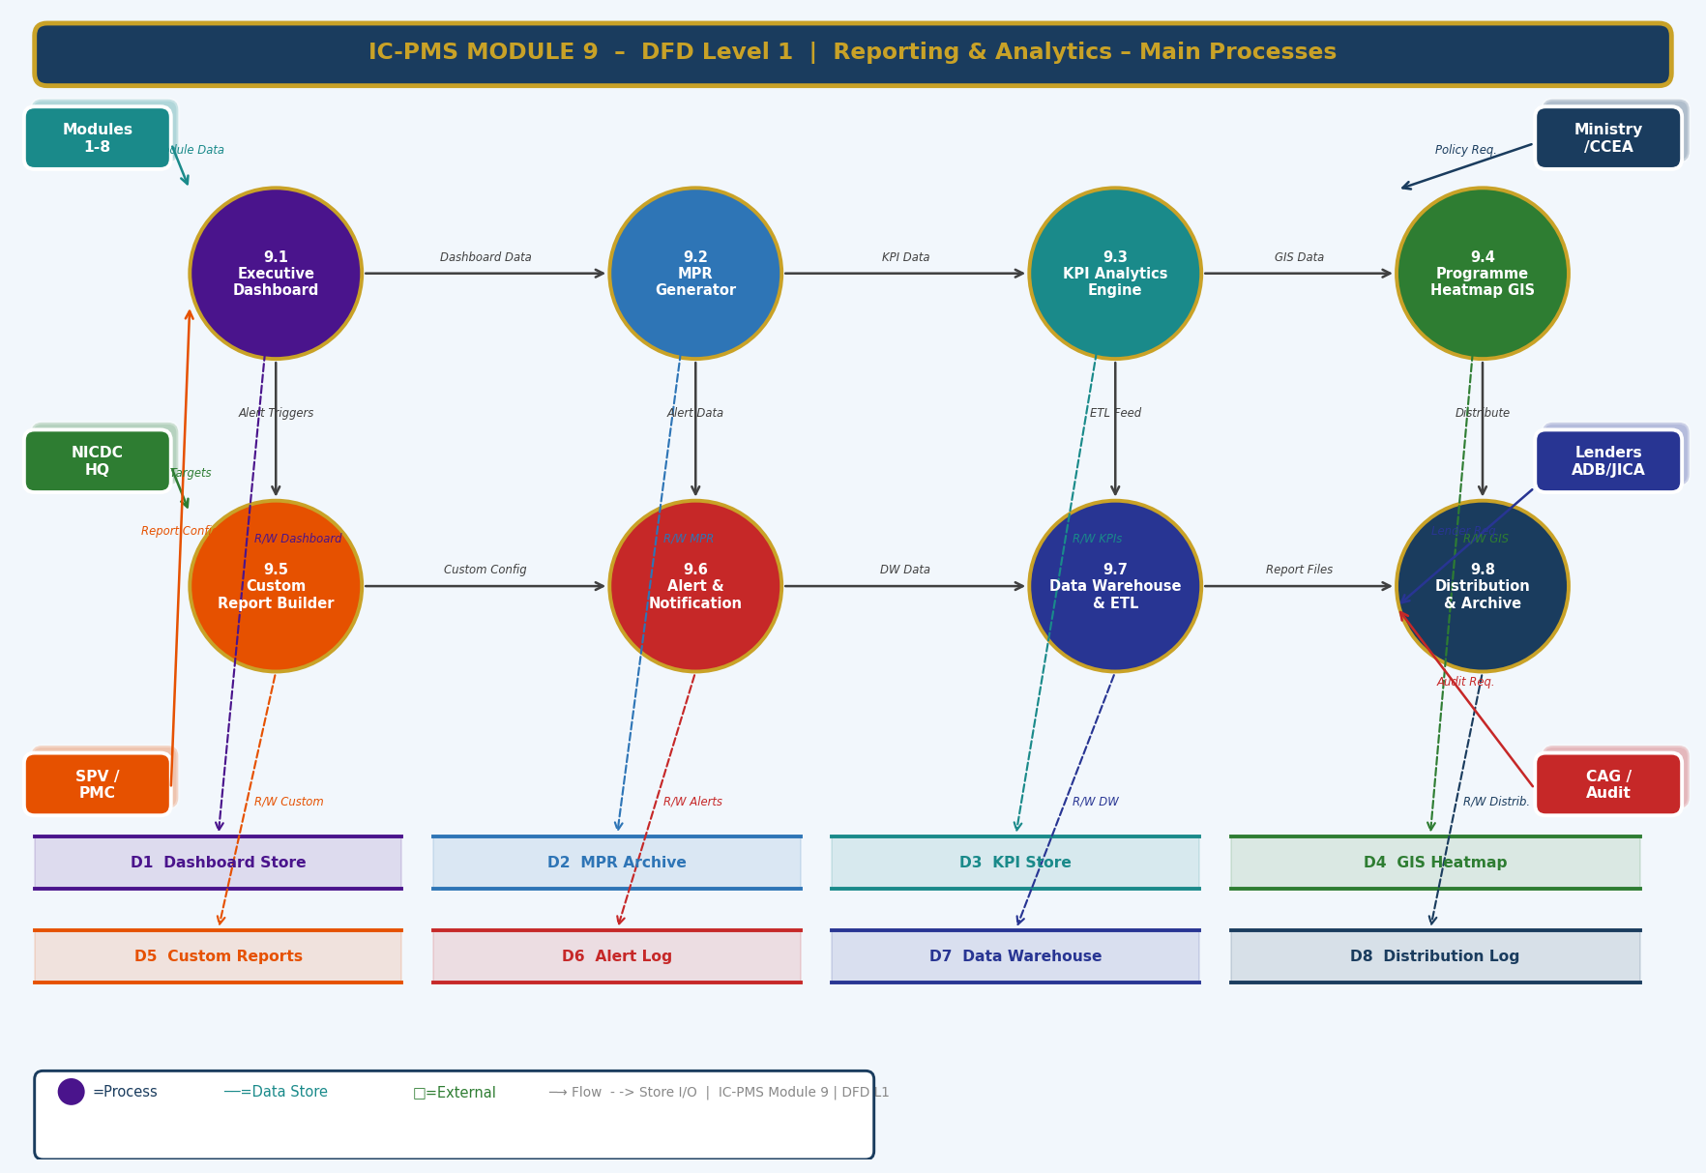
Figure 3.2 — DFD Level 1: Eight Core Processes and Eight Data Stores

Process and Data Store Descriptions
ID | Name | Function | Key Stores
9.1 | Executive Dashboard | Real-time configurable dashboard; role-based widget layouts; 15-min data refresh; drill-down navigation | D1 Dashboard Config, D7 DW
9.2 | MPR Generator | Auto-generates Monthly Progress Report; section assembly; AI narrative draft; review workflow; multi-format output | D2 MPR Archive, D7 DW
9.3 | KPI Analytics Engine | Computes 30 KPIs; trend detection; sparklines; benchmark comparisons; predictive alert generation | D3 KPI Store, D7 DW
9.4 | Programme Heatmap GIS | Geographic KPI visualisation; India corridor map; node click drill-down; time animation | D4 GIS Heatmap, D7 DW
9.5 | Custom Report Builder | Drag-and-drop no-code report design; widget palette; scheduling; sharing; template library | D5 Custom Reports, D7 DW
9.6 | Alert & Notification Engine | KPI threshold monitoring; event-triggered alerts; multi-channel delivery; acknowledgement tracking | D6 Alert Log, D7 DW
9.7 | Data Warehouse & ETL | ETL from Modules 1–8; star schema DW; historical snapshots; data lineage; Airflow orchestration | D7 Data Warehouse
9.8 | Distribution & Archive | Report delivery management; email/SMS/portal/API channels; DMS auto-archive; lender reporting | D8 Distribution Log, Module 6 DMS

3.3 DFD Level 2 — Process 9.2: MPR Generator (Exploded)
The Level 2 DFD drills into the MPR Generator — the most complex automated business process in Module 9. It shows all eight sub-processes from data collection through EVM compilation, satellite section, risk section, chart generation, AI narrative drafting, review/approval, and publish/distribution — with a completeness check decision diamond that determines whether to proceed or request missing data.
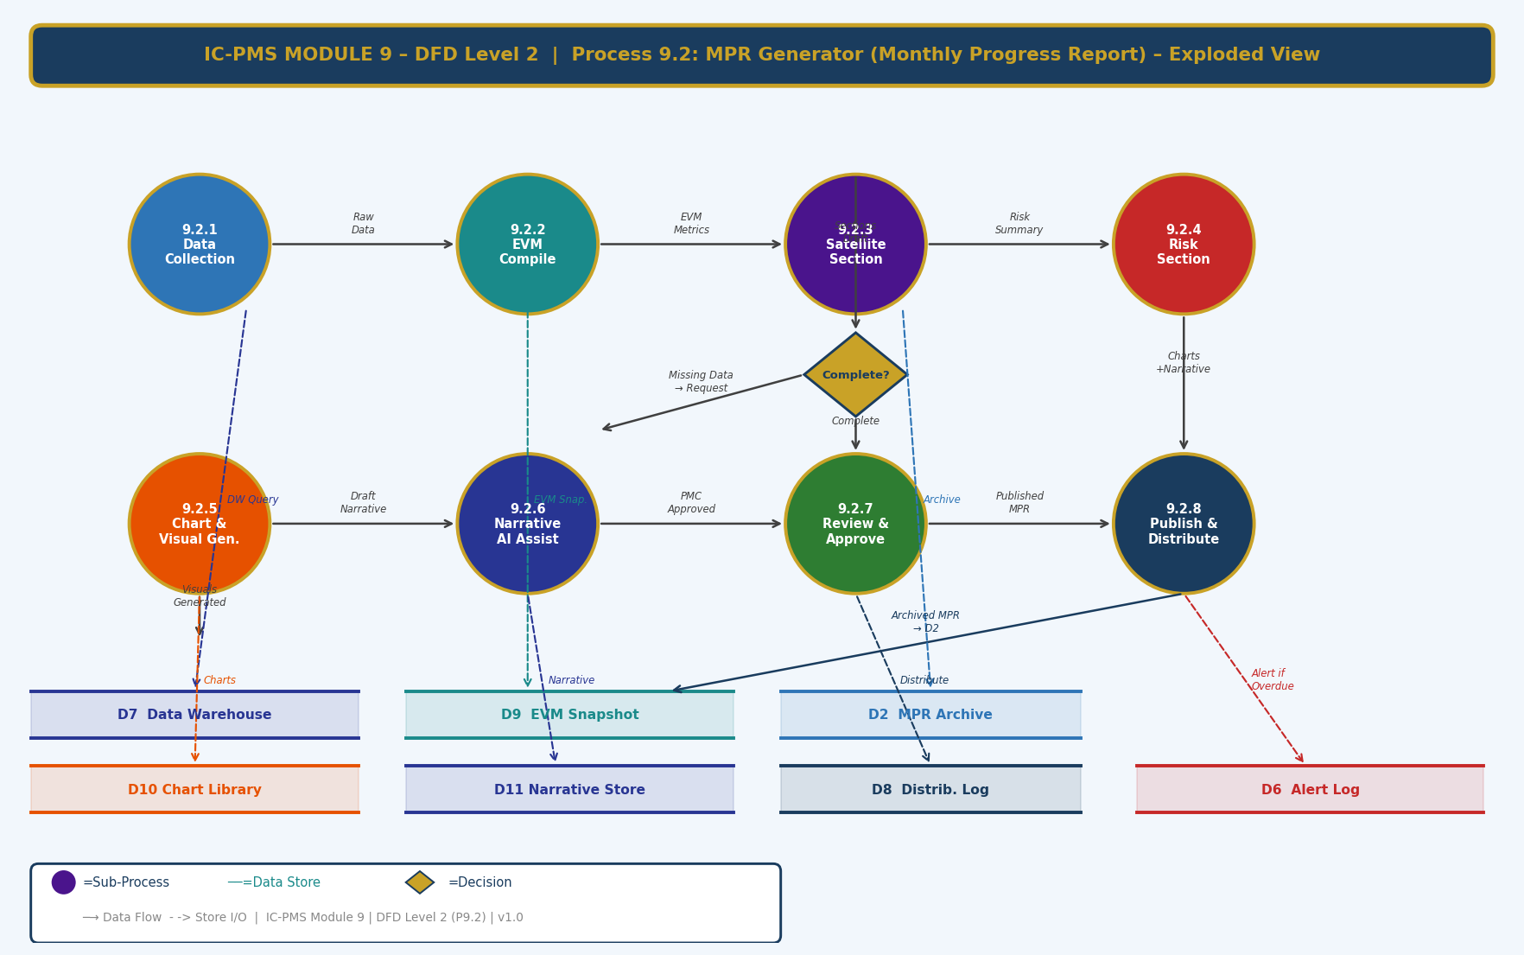
Figure 3.3 — DFD Level 2: Process 9.2 MPR Generator — 8 Sub-Processes with Data Completeness Decision

Sub-Process Narrative
Sub-Process | Name | Description
9.2.1 | Data Collection | Queries the Data Warehouse (D7) for the previous month's data across all required modules: Module 2 EVM snapshot, Module 3 AI progress, Module 4 expenditure, Module 5 contract status, Module 6 document KPIs, Module 7 risk register, Module 8 resource data. Validates completeness — if any module's data is more than 3 days stale in D7, the ETL is triggered immediately before proceeding.
9.2.2 | EVM Compile | Assembles the EVM section of the MPR: BCWS, BCWP, ACWP, SPI, CPI, EAC per WBS node and package. Retrieves the previous month's EVM snapshot from D9 for trend comparison. Flags any SPI < 0.85 or CPI < 0.85 values for RED highlighting. Computes month-on-month SPI/CPI delta.
9.2.3 | Satellite Section | Retrieves latest satellite AI progress % and contractor claimed % from Module 3. Computes discrepancies. Assembles the satellite section with: node-wise AI vs. contractor table, latest satellite image thumbnails (fetched from Module 3 GeoServer), CVI bar chart data, NDVI trend data, encroachment alert summary.
9.2.4 | Risk Section | Retrieves top 10 RED/AMBER risks from Module 7. Fetches latest Monte Carlo P80 estimates. Computes new risks added and risks closed in the month. Retrieves trigger events fired in the month. Completeness check: if Monte Carlo has not been run in current month, flags section as 'MC Results Pending' and generates alert to PMC Risk Lead.
9.2.5 | Chart & Visual Generation | Python matplotlib generates all required charts as high-DPI PNG: S-curve (cumulative cost), SPI/CPI trend, node progress bar chart, risk heat map, Monte Carlo S-curve, labour histogram, drawing completion bar, procurement pipeline. Charts stored in D10 (Chart Library) with a hash to prevent duplicate generation.
9.2.6 | AI Narrative Assist | Sends structured data for each MPR section to the NIC MeghRaj LLM API. LLM generates first-draft narrative paragraphs for: Executive Summary, EVM analysis, Satellite update, Risk commentary. Output stored in D11 (Narrative Store) clearly tagged as 'AI Draft — Requires Review'. LLM prompt engineered to match NICDC MPR writing style and use precise project values.
9.2.7 | Review & Approve | Draft MPR (with AI narrative and charts) presented to PMC Lead in a section-by-section review interface. PMC Lead can edit narrative text, flag data concerns, and approve each section individually. Final MPR requires SPV Director digital countersign (Aadhaar eSign). System tracks review time; if not completed within 2 working days, escalation to SPV PM.
9.2.8 | Publish & Distribute | Approved MPR assembled into final PDF/Word/HTML formats with NICDC letterhead and classification markings. Published to NICDC portal (D8 Distribution Log). Email distribution to configured list. Lender reports generated (if month is a lender reporting month). Archived to Module 6 DMS. Alert sent to all recipients with portal link.

4. Master Data Model

4.1 Entity Relationship Overview
The Module 9 master data model contains twelve entities. The Data Warehouse Table Registry (DW_TABLE_REGISTRY) and ETL Job Log are the infrastructure entities; Dashboard Config, MPR Record, KPI Snapshot, GIS Heatmap Record, Custom Report, and Alert Record are the operational entities; Distribution Log, Dashboard Widget, KPI Definition, and Subscription are the configuration and audit entities.
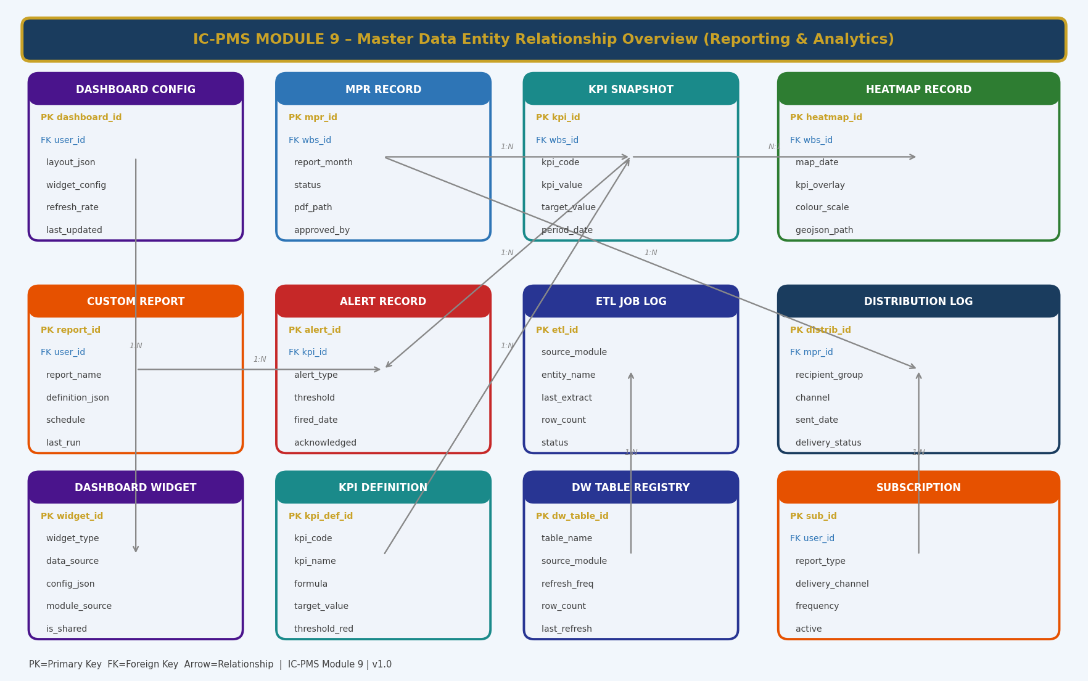
Figure 4.1 — Master Data Entity Relationship Overview (Module 9 — Reporting & Analytics)

4.2 Core Entity Field Definitions

4.2.1 Dashboard Configuration
dashboard_id | UUID — Primary Key
user_id | FK → User — the user or role this dashboard config belongs to
dashboard_name | VARCHAR — name of the dashboard (e.g. 'NICDC MD Programme View')
layout_json | JSONB — grid layout definition: position, size, z-index of each widget
widget_config | JSONB — array of widget IDs with their individual configuration settings
scope_filter | JSONB — default scope (corridor/node/package) applied to all widgets on this dashboard
refresh_rate_min | INTEGER — data refresh interval in minutes (5, 15, 60, 1440)
is_default_for_role | ENUM — NULL if personal; role name if this is the default layout for a role
is_shared | BOOLEAN — true if this dashboard config is shared with others
last_updated | TIMESTAMP — when layout was last modified
last_viewed | TIMESTAMP — when user last opened this dashboard
theme | ENUM: Dark / Light — dark theme for operations rooms; light for office/print

4.2.2 MPR Record
mpr_id | UUID — Primary Key
wbs_id | FK → WBS Element — the scope (corridor/node) this MPR covers
report_month | DATE — first day of the reporting month
status | ENUM: Data_Collection / Draft / PMC_Review / SPV_Review / Approved / Published / Archived
data_date | DATE — the EVM data date used for this MPR
generation_start | TIMESTAMP — when automated generation began
generation_end | TIMESTAMP — when generation pipeline completed
sections_complete_json | JSONB — boolean flags per section indicating AI draft completion
pdf_path | VARCHAR — NIC DigiLocker path to final approved PDF
word_path | VARCHAR — NIC DigiLocker path to Word version
html_path | VARCHAR — URL of HTML dashboard version
pmc_approved_by | FK → User — PMC Lead who approved the draft
pmc_approval_date | TIMESTAMP
spv_approved_by | FK → User — SPV Director who countersigned
spv_approval_date | TIMESTAMP
distribution_sent_date | TIMESTAMP — when final MPR was distributed

4.2.3 KPI Snapshot
kpi_id | UUID — Primary Key
kpi_def_id | FK → KPI Definition — the KPI being recorded
wbs_id | FK → WBS Element — scope for this KPI value (node/package/corridor)
period_date | DATE — the date/period this snapshot represents
kpi_value | DECIMAL(15,4) — the computed KPI value
target_value | DECIMAL(15,4) — the target value at this period date
green_threshold | DECIMAL(15,4) — green/amber boundary
red_threshold | DECIMAL(15,4) — amber/red boundary
rag_rating | ENUM: Green / Amber / Red — computed from kpi_value vs. thresholds
trend_direction | ENUM: Improving / Stable / Deteriorating — from 6-period regression
projected_breach_date | DATE — predicted date to reach Red threshold at current trend; NULL if not breaching
source_module | ENUM: M1/M2/M3/M4/M5/M6/M7/M8 — which module provided the source data
computed_at | TIMESTAMP — when this KPI value was computed

4.2.4 Alert Record
alert_id | UUID — Primary Key
kpi_id | FK → KPI Snapshot — the KPI that triggered this alert (if KPI-based)
custom_report_id | FK → Custom Report — if alert is from a custom report threshold
alert_type | ENUM: KPI_Red / KPI_Amber / Risk_Trigger / Payment_Delay / Document_Overdue / ETL_Failure / BG_Expiry / Encroachment
alert_title | VARCHAR — concise alert headline
alert_detail | TEXT — full description of the alert condition
source_module | ENUM: M1–M9
priority | ENUM: P1_Emergency / P2_Urgent / P3_Warning / P4_Info
fired_date | TIMESTAMP — when the alert was generated
delivery_channels_json | JSONB — list of channels used: Email / SMS / In-App / Portal / WhatsApp
delivered_to_json | JSONB — list of users / roles the alert was sent to
acknowledged_by | FK → User — first person to acknowledge
acknowledgement_date | TIMESTAMP
resolved_date | DATE — when the underlying condition was resolved
is_duplicate | BOOLEAN — true if this alert was suppressed as a duplicate within deduplication window

4.2.5 KPI Definition
kpi_def_id | UUID — Primary Key
kpi_code | VARCHAR — e.g. SPI, CPI, AI_PROG_PCT, RED_RISK_COUNT
kpi_name | VARCHAR — human-readable name: 'Schedule Performance Index'
kpi_dimension | ENUM: Schedule / Cost / Progress / Risk / Contract / Resource / Document
formula | TEXT — human-readable formula description or SQL expression for DW computation
data_source_module | ENUM — primary module providing source data
unit | VARCHAR — %, days, ₹ Cr, count, Ha/wk
green_target | DECIMAL — default green threshold
amber_threshold | DECIMAL — default amber threshold
red_threshold | DECIMAL — default red threshold
higher_is_better | BOOLEAN — true for SPI (higher better); false for Red Risk Count (lower better)
is_active | BOOLEAN — true if KPI is currently being computed
display_precision | INTEGER — decimal places for display
kpi_owner_role | VARCHAR — role responsible for this KPI (e.g. PMC Lead, SPV Finance)

4.2.6 ETL Job Log
etl_id | UUID — Primary Key
source_module | ENUM: M1 through M8
entity_name | VARCHAR — the specific table or data entity being extracted
job_start | TIMESTAMP — when ETL job started
job_end | TIMESTAMP — when ETL job completed; NULL if running
status | ENUM: Running / Completed / Failed / Retrying
rows_extracted | INTEGER — number of rows extracted from source
rows_loaded | INTEGER — number of rows successfully loaded to DW
rows_rejected | INTEGER — rows rejected due to validation rules
validation_errors_json | JSONB — details of any data quality validation failures
retry_count | INTEGER — number of retry attempts if failed
dw_table_refreshed | VARCHAR — DW fact/dimension table updated by this job
data_freshness_minutes | INTEGER — age of source data in minutes at time of extraction

5. UI/UX Screen Designs
Module 9 delivers five primary screens covering the main reporting and analytics workflows. The module uses deep violet (#4A148C) as its identity colour — reflecting the analytical, intelligence-gathering nature of programme reporting. The design philosophy is 'progressive disclosure' — the most critical information is visible at a glance; detail is accessible in two clicks; raw data is accessible in three. All screens are available in both desktop (full-width, data-dense) and mobile (simplified, executive summary) views.

Screen 1 — NICDC Programme Executive Dashboard
The Executive Dashboard is designed for the NICDC Programme Director and Ministry officials who need a sub-30-second status read of the entire industrial corridor programme. It combines the programme S-curve, per-node progress bars with AI vs. plan comparison, a 6-module RAG health summary, and a live alert feed — all refreshing every 15 minutes from live module data.
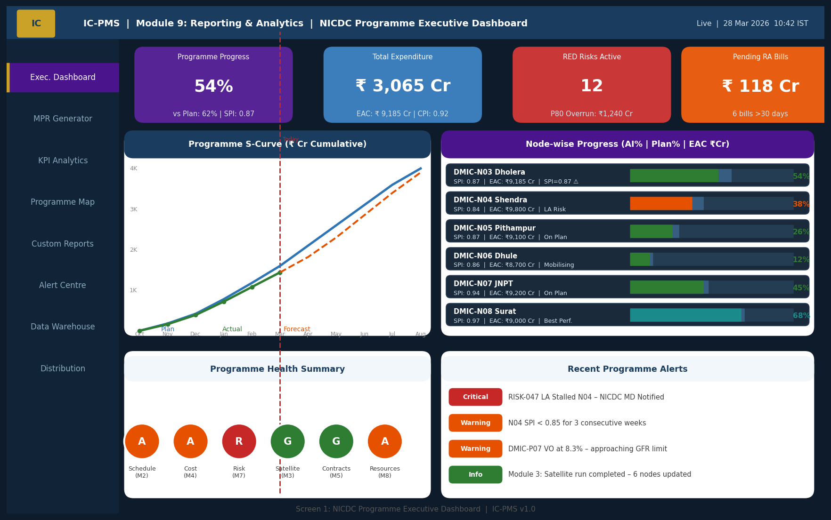
Figure 5.1 — Executive Dashboard (KPI Cards, Programme S-Curve, Node Progress Bars, RAG Health, Alert Feed)

Executive Dashboard UI Components
Component | Description | Interaction
KPI Cards (4 — top row) | Programme Progress %, Total Expenditure (EAC), RED Risks Active, Pending RA Bills. Each card shows the key value, a contextual sub-figure, and a colour indicating RAG status. | Click any card to navigate to the detail module (e.g., Progress card → Module 2/3 combined view)
Programme S-Curve | Three-line cumulative cost chart: Planned (blue), Actual (green), Forecast (orange dashed). Red vertical line = today. Fills under lines show zones. | Hover for exact values at any month; click to expand to full-screen Module 4 cost analytics
Node Progress Bars | Per-corridor-node horizontal progress bar showing AI-verified progress (coloured fill) against plan target (background fill). SPI, EAC, and status note per row. | Click any node row to navigate to that node's detailed operational dashboard
Programme Health RAG | Six coloured circles — one per module — showing Green/Amber/Red status based on worst KPI in each module. Provides instant programme-wide health scan. | Click any RAG circle to navigate to that module's KPI analytics
Live Alert Feed | Real-time feed of programme alerts ordered by priority. Each alert shows type badge, message, and time. Clicking alerts navigates to relevant screen. | Click any alert to open the originating module screen or risk/document detail

Screen 2 — MPR Generator & Preview
The MPR Generator screen provides the full MPR assembly environment — a configuration panel on the left, a step-by-step generation progress bar at the top, and a live report preview on the right showing the actual MPR content as it is assembled. PMC Leads use this screen for monthly MPR review and approval.
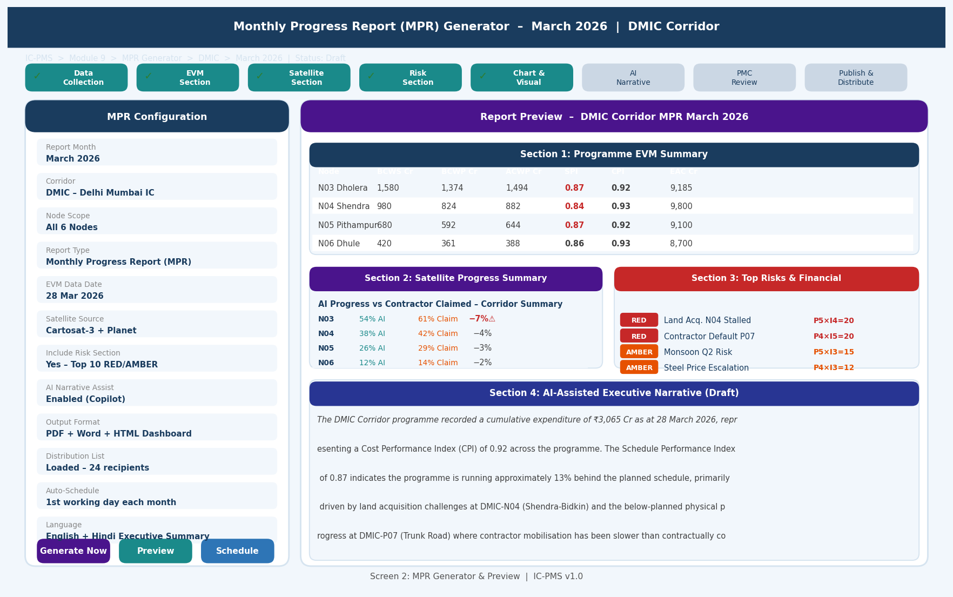
Figure 5.2 — MPR Generator (Configuration Panel, Generation Step Tracker, Live Preview with EVM Table, Satellite, Risk, AI Narrative)

MPR Generator Screen Design
- Generation progress bar: Eight-step progress tracker at the top — each step shows green tick (complete), active state (current), or grey (pending). Non-linear generation (some sections can be generated in parallel) handled by showing parallel steps at the same level
- Configuration panel (left): Scrollable list of report parameters — all pre-populated from the last successful MPR but editable before triggering generation. Generate/Preview/Schedule buttons at bottom.
- Live preview (right): As each section is generated, it appears in the preview panel — MPR assembles visually in real time. EVM table, satellite summary, risk section, and AI narrative all visible before final review
- AI narrative indication: AI-generated narrative text shown with subtle purple highlight and 'AI Draft' badge — clearly distinguishable from human-written content; single-click to enter edit mode
- Section approval checkboxes: In review mode, each MPR section has an approval checkbox visible only to the PMC Lead — section-by-section approval before final sign-off
- Hindi summary preview: Collapsible panel showing the auto-translated Hindi executive summary at the bottom of the preview

Screen 3 — KPI Analytics Engine
The KPI Analytics screen presents all 30 programme KPIs as a 3×3 grid of sparkline cards — each card showing the current value, target, trend direction, and a 7-period sparkline chart. The colour of each card's header immediately communicates the RAG status of that KPI. This is the 'programme vital signs' screen.
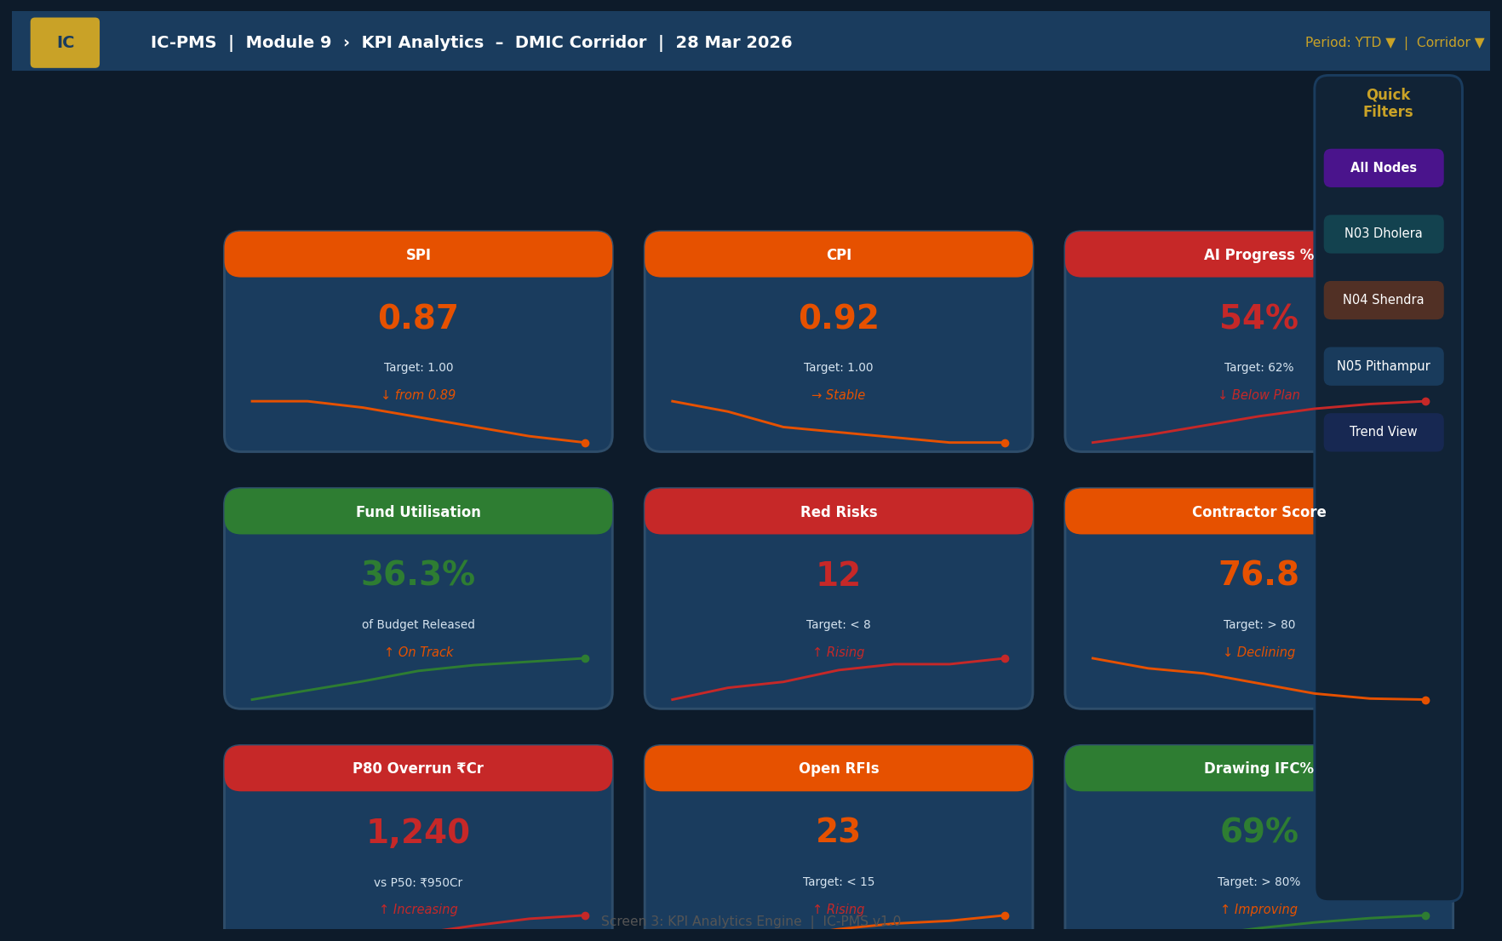
Figure 5.3 — KPI Analytics Engine (9-Card Sparkline Grid, Trend Arrows, Quick Filters, RAG Colour Coding)

KPI Analytics Screen Design
Feature | Description
Card colour header | Each KPI card has a coloured top header: violet (Green KPI), orange (Amber KPI), red (Red KPI). The most important visual signal — card colour communicates health without reading numbers.
Sparkline chart | 7-period line sparkline at the bottom of each card, colour-matched to the KPI colour. Upward slope on a positive-direction KPI (like SPI) = improving. Downward slope = deteriorating.
Trend arrow | Arrow icon below the KPI value: ↑ (improving), → (stable), ↓ (deteriorating). Coloured green/amber/red based on direction and KPI type.
Target vs. Actual | Two-line display: Current value (large, bold) on top; Target value (smaller) below. Gap between them is immediately apparent.
Click to expand | Clicking any KPI card expands to a full-screen detail view showing: 12-month trend chart, benchmark comparison across all nodes, projected threshold breach date, top 3 activities contributing to the KPI, and link to source module.
Quick filters (right panel) | Node/Corridor selector and Trend-only filter; changes apply to all 9 visible cards simultaneously without navigating away.

Screen 4 — Programme GIS Heatmap
The Programme GIS Heatmap provides a geographical intelligence view of the entire industrial corridor programme — showing which parts of India's corridor network are performing well and which are struggling. It is designed for Ministry briefings, NICDC Board presentations, and lender quarterly reviews.
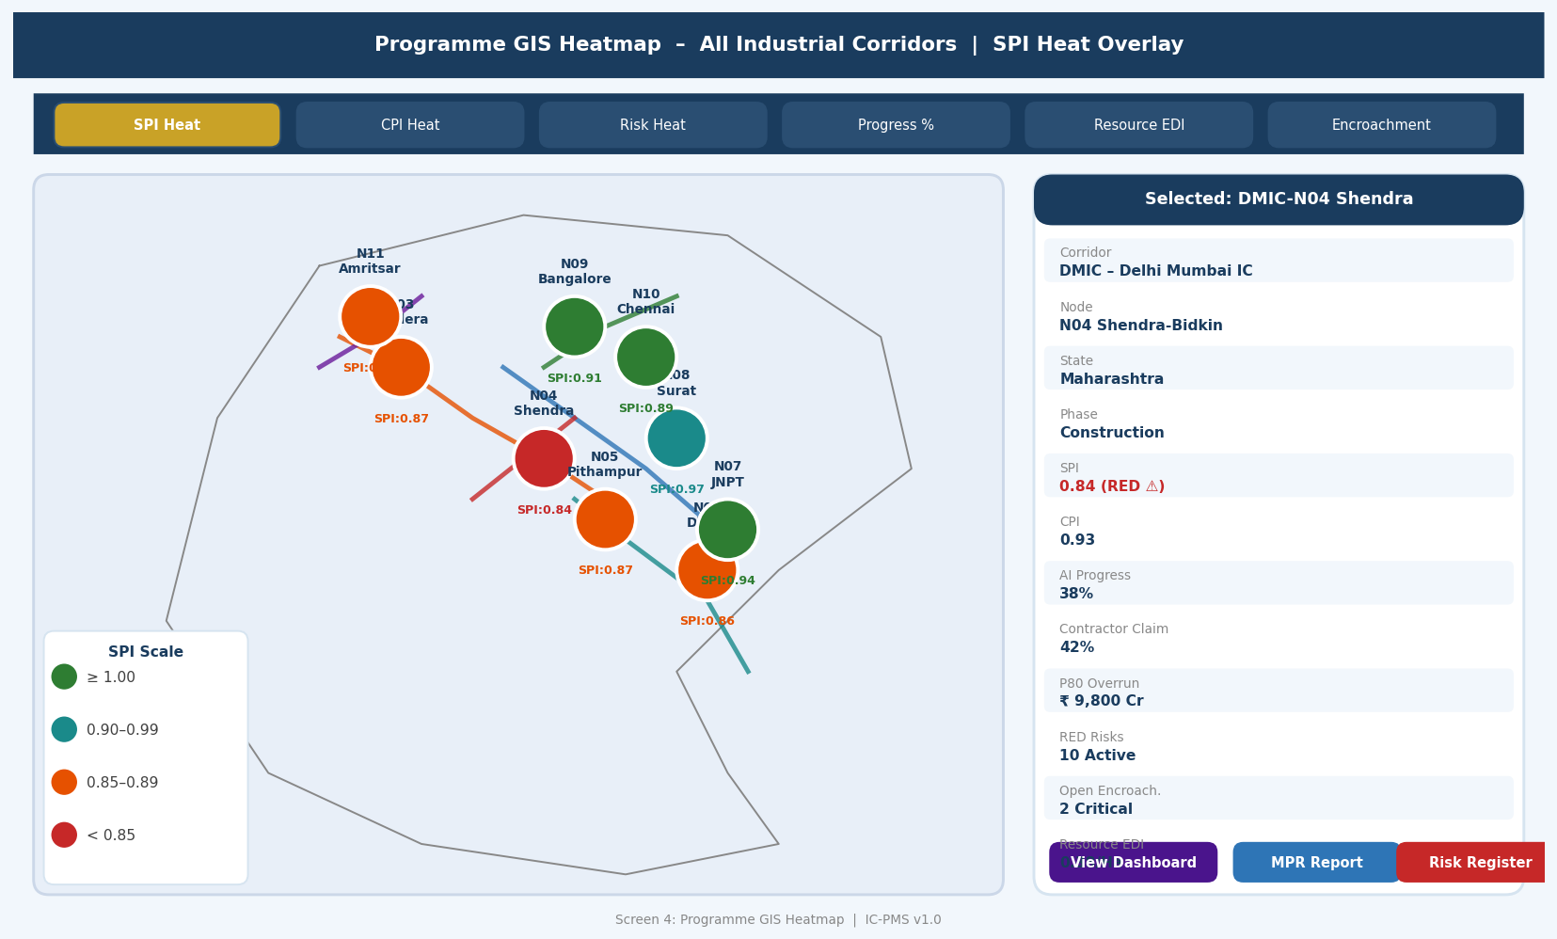
Figure 5.4 — Programme GIS Heatmap (India Map with Corridor Overlays, SPI Heat Coding, Node Detail Panel, KPI Comparison Table)

GIS Heatmap Screen Design
- Corridor alignment lines: Each corridor shown as a coloured polyline on the India map — immediately communicates the geographic scope and relative position of each corridor
- SPI-coded node circles: Each node shown as a colour-coded circle (green/teal/orange/red based on SPI value) — size proportional to budget; SPI and node code shown as labels
- KPI overlay selector: Tabs at the top allow switching the colouring scheme between SPI, CPI, AI Progress, Risk Rating, EDI, and Encroachment Count — same map, different intelligence overlay
- Node click panel: Clicking a node opens a right-side detail panel with all key KPIs, satellite image thumbnail, and navigation buttons — the map is an entry point to operational detail
- Time animation button: 'Play' animates the map through 12 monthly SPI snapshots — watching the colour change across the corridor map tells a compelling story about programme trajectory
- Ministry export: 'Export for Presentation' generates a clean PNG with all overlays, corridor labels, and legend — optimised for PowerPoint embedding in Ministry briefings

Screen 5 — Custom Report Builder
The Custom Report Builder is a no-code drag-and-drop report design interface — comparable to Microsoft Power BI's report builder but designed specifically for the IC-PMS data model and Indian government reporting conventions. It empowers NICDC programme managers and SPV finance teams to build their own reports without IT involvement.
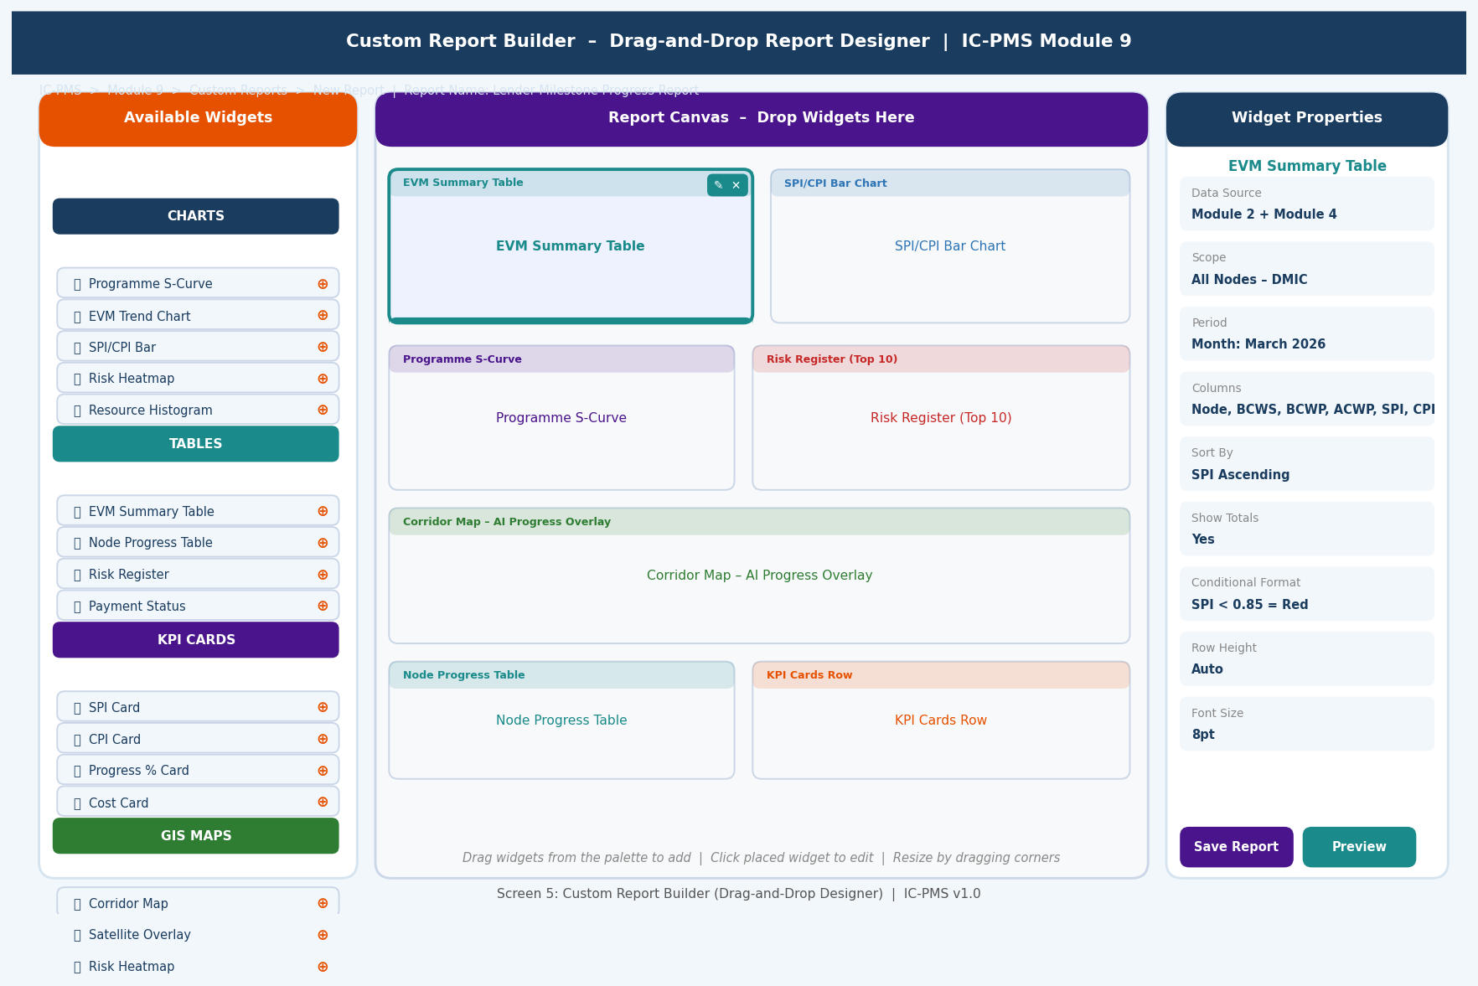
Figure 5.5 — Custom Report Builder (Widget Palette, Report Canvas, Properties Panel, Drag-and-Drop Layout)

Report Builder UX Design Principles
- Three-panel layout: Left = widget palette (available building blocks); Centre = report canvas (the report being designed); Right = properties panel (configuration for the selected widget). The classic three-panel design used by all major BI tools — immediately familiar.
- Widget palette categories: Organised by data domain (Charts, Tables, KPI Cards, GIS Maps) — each widget shows the data it will display so users can pick the right building block
- Canvas snap-to-grid: Widgets snap to a background grid ensuring clean alignment without manual positioning; grid invisible to end-user but guides widget placement
- Selected widget highlight: The selected widget shows a coloured top bar and edit icons — making the currently active widget unambiguous; rest of canvas slightly faded
- Properties panel auto-updates: When a different widget is clicked on the canvas, the properties panel immediately shows that widget's settings — no separate selection step
- Live data preview: As configuration is entered in the properties panel, the widget on the canvas updates to show real data (or representative sample data for expensive queries)

6. Business Rules & Validation Logic

6.1 Dashboard & Report Data Quality Rules
Rule ID | Description | Outcome
RPT-001 | No report or dashboard value may be manually overridden by a user unless they are the NICDC KPI Administrator; all values must derive from module operational data | Blocking: 'Manual data entry is not permitted in IC-PMS reports. Update the source data in the originating module.'
RPT-002 | If a Data Warehouse ETL job for any module has not completed successfully in the last 48 hours, all dashboards and reports sourcing data from that module display a 'Stale Data' warning with the last-success timestamp | Warning banner on affected widgets: 'Module X data is 52 hours old (last updated: [date/time]). Run ETL to refresh.'
RPT-003 | Monthly Progress Report may only be published after both PMC Lead section approval and SPV Director countersign are recorded in the system | Blocking: 'MPR cannot be published. Missing: SPV Director countersign. Send for approval.'
RPT-004 | AI-generated narrative sections must be reviewed and approved by the PMC Lead before inclusion in the published MPR; AI text cannot be published unreviewed | Blocking: 'Section 1 (Executive Summary) contains unreviewed AI narrative. Review and approve before publishing.'
RPT-005 | KPI alert thresholds can only be modified by the NICDC KPI Administrator role; changes trigger a 30-day audit trail and notification to NICDC Programme Director | Audit log: 'SPI Red Threshold changed from 0.85 to 0.80 by [user] at [timestamp]. Reason: [mandatory justification]'

6.2 Distribution & Access Control Rules
Rule ID | Description | Outcome
RPT-006 | External reports (lenders, Ministry, CAG) may only be distributed after the internal approval workflow is complete; no external distribution of draft MPRs | Blocking: 'External distribution blocked. MPR status is Draft. Complete approval workflow first.'
RPT-007 | Reports marked Confidential (LOA values, financial details, legal documents) are distributed as password-protected encrypted PDFs; password communicated to recipients through a separate channel | System auto-encrypts PDF; password generated and stored in Module 6 DMS; separate delivery of password via pre-configured secure channel
RPT-008 | Custom report access is governed by the originating module's access rules — a custom report using Module 4 (Cost) data can only be viewed by users who have Module 4 financial data access rights | Blocking at report view time: 'You do not have access to view financial data included in this report.'
RPT-009 | The Data Warehouse must be replicated to a secondary NIC data centre; primary DW unavailability must not prevent dashboard access for > 15 minutes | Automatic failover to secondary DW replica; monitoring alert if primary DW unavailable > 5 minutes

6.3 Alert & Notification Rules
Rule ID | Description | Outcome
RPT-010 | P1 (Emergency) alerts must be delivered within 15 minutes of the triggering event; delivery failure after 3 retries escalates to NICDC IT emergency hotline | Alert delivery monitoring; escalation to IT hotline after 3 failed delivery attempts across all channels
RPT-011 | Alert deduplication window: if the same alert type fires for the same KPI/scope within a 4-hour window, only one alert is sent; subsequent firings logged but not re-delivered | Deduplication prevents alert fatigue; consolidated alert with 'fired N times' note sent at end of deduplication window
RPT-012 | Unacknowledged P1 alerts auto-escalate to the recipient's supervisor after 30 minutes; unacknowledged P2 alerts escalate after 2 hours | Escalation log entry; supervisor notification with original alert details and non-acknowledgement duration

7. Integration Touchpoints

7.1 Module Data Feeds to Data Warehouse
Source Module | Data Entities Extracted | ETL Frequency | DW Fact Table
Module 1 — WBS | WBS hierarchy, OBS structure, corridor/node/package master | Daily at 02:00 | DIM_WBS, DIM_ORGANISATION
Module 2 — Scheduling | Activity list, BCWS/BCWP time-phased values, SPI/CPI, Total Float, milestone status | Every 15 minutes (near real-time) | FACT_EVM, DIM_ACTIVITY
Module 3 — Satellite | AI progress % per WBS, CVI, EDI, encroachment alerts, NDVI values | Weekly (per satellite cycle) | FACT_SATELLITE, FACT_PROGRESS
Module 4 — Cost | ACWP by WBS, EAC, invoice status, PFMS payment log, VO register | Every hour | FACT_COST, FACT_PAYMENT
Module 5 — Contract | Contract status, milestones, VO %, contractor scorecard, BG expiry | Daily at 02:00 | FACT_CONTRACT, FACT_MILESTONE
Module 6 — DMS | Document counts, Drawing IFC%, RFI ageing, transmittal overdue | Daily at 02:00 | FACT_DOCUMENT
Module 7 — Risk | Risk register (RED/AMBER/GREEN count), P80 MC estimate, trigger log | Daily at 02:00; Real-time for P1 triggers | FACT_RISK, FACT_MONTE_CARLO
Module 8 — Resource | Labour deployment, equipment utilisation, material reconciliation, over-allocation count | Every hour | FACT_RESOURCE, FACT_EQUIPMENT

7.2 Module 9 Outputs to Other Modules
Target Module | Data Provided | Use Case
Module 6 — DMS | All generated reports (MPR, KPI, custom, lender) auto-archived | Every published report filed under relevant WBS folder in Module 6 with Permanent/Long-term retention class
Module 7 — Risk | Alert trigger data used in Module 7 trigger log; KPI breach alerts cross-referenced | P1/P2 alert events recorded in Module 7 Trigger & Escalation Log for audit trail
All Modules (Subscriptions) | Data completeness feedback: if DW shows missing data from a module, alert generated to that module's data owner | Proactive data quality enforcement across all modules

7.3 External System Integrations
System | Integration | Data Flow | Notes
NICDC Web Portal (CMS) | REST API push | Published MPRs, dashboards, and reports pushed to NICDC's public/internal web portal | Portal CMS API; SSO via NIC SSO; content staging before publish
ADB / JICA Lender Portals | SFTP + REST API | Quarterly lender reports and monthly progress tables delivered to lender monitoring portal in their required format | Lender-specific credentials; report formats pre-agreed with lenders
NIC SMS Sevak | REST API | P1/P2 alert SMS delivery; MPR publication notification to key stakeholders | Government SMS gateway; character-limited format; DLT registered sender ID
NIC LLM Service (MeghRaj) | REST API — internal NIC cloud | AI narrative generation requests for MPR sections; structured data sent, narrative text received | NIC MeghRaj sovereign LLM; no data leaves government infrastructure; LLM model versioned
Ministry of Commerce PIMS | REST API | Selected MPR KPIs pushed to Ministry's own Programme Information Management System | Ministry API credentials; push on MPR publication; KPI subset defined by Ministry
CAG Digital Audit System | SFTP | Annual audit packages (DW snapshot + document index) delivered to CAG digital audit system | CAG secure SFTP; encrypted package; digital signature on index

8. Workflow & Approval Chains

8.1 MPR Review and Publication Workflow
Step | Actor | Action | SLA
1 — Auto-Generation | System (CronJob) | Generate complete draft MPR from DW snapshot; AI narrative drafts added | 02:00 IST on 1st of month
2 — Data Quality Check | System | Validate all sections complete; send alert for any missing module data | By 04:00 IST on 1st
3 — PMC Lead Review | PMC Risk + Analytics Lead | Review each section; edit AI narrative as needed; flag data concerns | By end of day 2 (3rd of month)
4 — PMC Lead Approval | PMC Lead (Aadhaar eSign) | Section-by-section approval with digital signature | By 3rd of month
5 — SPV Director Review | SPV Director | Review complete MPR; raise any concerns with PMC Lead | By 4th of month
6 — SPV Director Countersign | SPV Director (DSC) | Countersign MPR with USB DSC; MPR status = Approved | By 5th of month (working day)
7 — Publication | System | Generate final PDF/Word/HTML; distribute to list; archive to DMS | Within 2 hours of SPV countersign
8 — External Distribution | System | Lender reports if applicable; Ministry portal update | Same day as internal publication

8.2 Custom Report Approval and Sharing
Report Type | Creator | Approval Required | Distribution
Internal operational report | Any authorised user | No approval (stays within access rights) | Self-publish; share with colleagues of same or lower access level
Report shared externally (lenders) | SPV PM / NICDC Finance | SPV Director approval before external distribution | Distributed via lender portal SFTP after approval
Report including financial detail (LOA values, payments) | SPV Finance / NICDC Finance | NICDC Finance Director approval for external sharing | Encrypted PDF; password in separate channel
Ministry / CCEA briefing note | NICDC PMO | NICDC MD sign-off | Ministry portal; direct email to Secretary-level

9. Performance & Non-Functional Requirements
Requirement | Specification | Measurement
Executive dashboard load time | < 3 seconds to render full dashboard with all live widgets on desktop; < 5 seconds on mobile | Lighthouse audit; P95 at 200 concurrent users
KPI refresh latency (Module 2 data) | Dashboard KPI values no more than 15 minutes behind live Module 2 data | ETL completion time + rendering time < 15 minutes
MPR auto-generation time | Complete draft MPR (all sections + charts + AI narrative) generated in < 10 minutes | Pipeline completion timestamp; measured monthly
AI narrative generation (per section) | < 60 seconds per MPR section narrative draft from NIC MeghRaj LLM | LLM API call completion time
Full DW query response time | < 5 seconds for any programme-level aggregation query (e.g., total BCWP across all nodes) | PostgreSQL query plan; Elasticsearch aggregation time
Custom report render time | < 10 seconds to render a 10-widget custom report with live DW data | Report render pipeline time
Alert delivery latency (P1) | < 15 minutes from trigger event to confirmed delivery (email + SMS) | End-to-end alert pipeline timing; monitored per alert
Data warehouse uptime | 99.5% uptime; automatic failover to secondary replica in < 15 minutes | Synthetic monitoring; monthly SLA report to NICDC IT
Concurrent dashboard users | 500 simultaneous users across all roles and corridors without degradation | k6 load test at 500 VUs; 30-minute sustained load
Report archive retrieval | Any archived report (including 10-year-old MPR) retrievable in < 30 seconds via Module 6 DMS link | Module 6 DMS retrieval SLA; NIC MeghRaj warm storage

10. Glossary — Module 9 Terms
Term | Definition
Data Warehouse (DW) | A denormalised, query-optimised copy of operational data from all modules, structured for fast analytical reporting without impacting operational system performance
ETL | Extract, Transform, Load — the process of pulling data from source systems (Modules 1–8), applying transformations (joining, aggregating, cleaning), and loading into the Data Warehouse
Apache Airflow | Open-source workflow orchestration platform used to schedule and monitor ETL pipelines; each module's ETL is configured as an Airflow DAG (Directed Acyclic Graph)
Star Schema | A data warehouse design pattern with central fact tables (e.g., FACT_EVM) linked to dimension tables (e.g., DIM_WBS, DIM_DATE); optimised for analytical query performance
KPI | Key Performance Indicator — a specific, measurable value that tracks performance against a target; Module 9 maintains 30 programme-level KPIs across 6 dimensions
RAG Status | Red/Amber/Green traffic light status — a three-level health indicator used throughout IC-PMS to instantly communicate performance status
SPI | Schedule Performance Index — EVM metric = BCWP / BCWS; SPI < 1.0 indicates behind schedule; SPI > 1.0 indicates ahead of schedule
CPI | Cost Performance Index — EVM metric = BCWP / ACWP; CPI < 1.0 indicates over budget per unit of work; CPI > 1.0 indicates under budget
MPR | Monthly Progress Report — the primary monthly governance document for IC-PMS; covers physical progress, financial performance, schedule, satellite, risk, contract, resource, and document status
LLM | Large Language Model — an AI model capable of generating human-quality text from structured data; used in Module 9 for MPR narrative drafting; hosted on NIC MeghRaj (sovereign cloud)
AI Draft | Text generated by the LLM for MPR narrative sections; clearly labelled; must be reviewed and approved by PMC Lead before publication in any official document
Sparkline | A small, condensed line chart — typically 7 periods — that shows trend direction of a KPI without axis labels; used in the KPI analytics grid to provide instant visual trend recognition
GIS Heatmap | A geographic map where areas/points are colour-coded by the intensity of a selected KPI value — providing a spatial understanding of programme performance
Elasticsearch Watcher | Elasticsearch's alerting mechanism — configured rules continuously monitor the data warehouse; threshold breaches trigger alerts; used as the engine for Module 9's alert system
Point-in-time Snapshot | A complete copy of the Data Warehouse state at a specific date — used for historical reporting and 'as at [date]' queries required for audit and lender reporting
Data Lineage | The documented trail from any report value back to its source operational record — enabling auditors to verify that a reported figure is correctly derived from primary system data
Distribution List | A configured set of recipients (names, roles, email addresses) for a specific report type; versioned so that historical dispatch records accurately show who received each edition
NICDC Web Portal | NICDC's official website and internal programme portal where published MPRs, dashboards, and public progress updates are hosted for authorised stakeholders
Lender Monitoring Report | A specifically formatted quarterly report generated for each lender (ADB, JICA, World Bank) showing progress against their loan covenants, milestone payments, and financial utilisation
NeSDA | National e-Governance Service Delivery Assessment — the GoI framework for digital public services; Module 9 reports are aligned with NeSDA's data sharing and open government data standards

